Your primary role as the discussion leader is to get your team talking about why and how the concepts can be leveraged in the context of their situations. Please consider the following when using this guide:
- Use the questions in the Guiding the Discussion column, as well as any of your own design, to encourage your team members to share their challenges, experiences, and points of view.
- It will also be helpful to introduce your own perspective and experiences to highlight a key point, lesson learned, or best practice.
- The Points to Highlight column provides examples of question responses you may want to add to the discussion.
- Please note that the accompanying slides can be leveraged during the discussion, but are not necessary for an effective discussion. The slides can be helpful when leading a distributed group discussion via teleconference.
- Working through this guide can take up to 45 minutes. If you prefer a shorter 15- or 30-minute session, you may want to focus only on those concepts and activities most relevant to your situation.

Guiding the Discussion | Points to Highlight

Introduction (5 minutes)
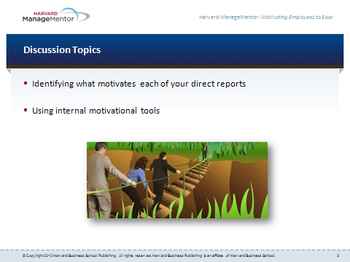
- We know that internal motivational tools are highly effective, so today we’re going to discuss how you can use internal motivational tools with your employees to keep them energized and moving forward toward important goals.  - What internal tools have you used, and how effective have they been? These could include challenging assignments, learning opportunities, positive feedback for a job well done, or a sense of ownership of the job. | - Example response:  - I once challenged an employee to take on a difficult stretch assignment that required him to learn some new skills. He was nervous about taking it on. But once he got into it and started scoring some successes, he got excited. He became very focused on the project and devoted a lot of energy to it, even though it was difficult and time-consuming.  - Note: Consider sharing your own experiences with using internal motivational tools.

What Motivates Each of Your Direct Reports? (20 minutes)
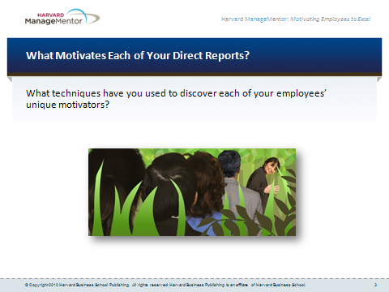
- People have individual drives, needs, and desires and thus are motivated by different things. To use internal motivational tools, you therefore need to find out what motivates each of your direct reports.  - What techniques have you used to discover your employees’ unique motivators? | - Example responses:  - I’ve just asked them what inspires them the most to excel at their work.  - I observe them, looking for signs of increased excitement and energy.  - I’ve invited them to use assessment tools that help them identify the job activities they find most satisfying and interesting.  - Note: Consider sharing your own experiences with things you’ve done to identify what best motivates each of your employees. If you feel uncomfortable discussing examples involving people who are in the room, cite examples involving people who used to report to you in a previous job or role, or one of your past manager’s techniques.
- Pair up with someone, and discuss what motivates your top two or three employees.  Reconvene as a group, and ask for a few volunteers to share what is motivating their key employees. | - Example responses:  - Achievement  - Positive feedback  - Interesting work  - Sense of ownership  - Opportunities to learn and grow

Using Internal Motivational Tools (20 minutes)
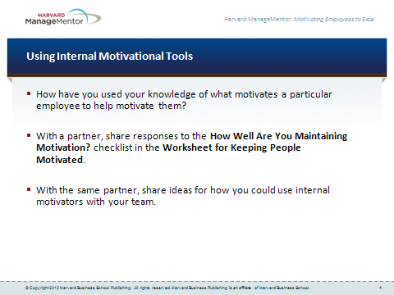
- Does someone have an example of how you have used your knowledge of what motivates a particular employee to help motivate them?  - Find a partner and share responses to the How Well Are You Maintaining Motivation? checklist in the Worksheet for Keeping People Motivated. This checklist introduces additional internal motivators.  - With the same partner, share ideas for how you could use the internal motivators with your team.  Reconvene as a group, and ask for a few volunteers to share insights from their discussion. | - Example response:  - I noticed that one of my employees seemed particularly enthusiastic whenever I asked her, “So how are your projects going?” This suggested to me that she enjoys feeling a strong sense of ownership of her work. So I started taking every opportunity to emphasize that sense of ownership. For example, I avoided micromanaging her, and left it up to her to come to me with any problems. And I kept referring to “your” projects, “your” work — using language that let her know that she was in charge of her responsibilities.  - Note: Consider sharing your own experiences with using a particular internal motivational tool with an employee. Also, try to elicit a range of stories and examples from group members that address various internal motivational tools.

next steps
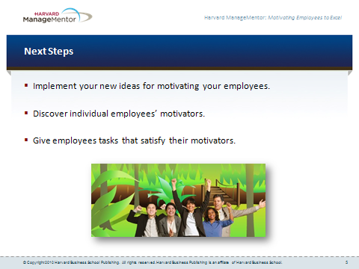
- Take a moment to consider some of the things you might do as a result of our discussion today in order to identify and activate the internal motivators most important to each of your employees. | - Think about the ideas you exchanged today with your partner for how to activate internal motivators with your employees. Make a commitment to apply several of those ideas over the next two weeks.  - Do you have one or more direct reports whose most powerful motivators you haven’t yet discovered? If so, in the coming week take steps to identify those individuals’ motivators using ideas discussed today.  - Pick an employee whose most powerful internal motivators you know. In the coming week, find an opportunity to give that person a task or assignment that will activate that motivator.

