Your primary role as the discussion leader is to get your team talking about why and how the concepts can be leveraged in the context of their situations. Please consider the following when using this guide:
- Use the questions in the Guiding the Discussion column, as well as any of your own design, to encourage your team members to share their challenges, experiences, and points of view.
- It will also be helpful to introduce your own perspective and experiences to highlight a key point, lesson learned, or best practice.
- The Points to Highlight column provides examples of question responses you may want to add to the discussion.
- Please note that the accompanying slides can be leveraged during the discussion, but are not necessary for an effective discussion. The slides can be helpful when leading a distributed group discussion via teleconference.
- Working through this guide can take up to 45 minutes. If you prefer a shorter 15- or 30-minute session, you may want to focus only on those concepts and activities most relevant to your situation.

Guiding the Discussion | Points to Highlight

Introduction
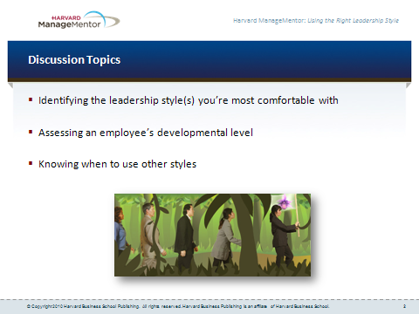
- Today we’re going to explore the leadership styles you gravitate toward while working with members of your team.
- We’ll share our experiences with assessing employees’ developmental levels.
- And we’ll explore how you can expand your repertoire of styles so you can select the right style for each employee’s developmental needs.

Identifying Your Natural Leadership Style (15 minutes)
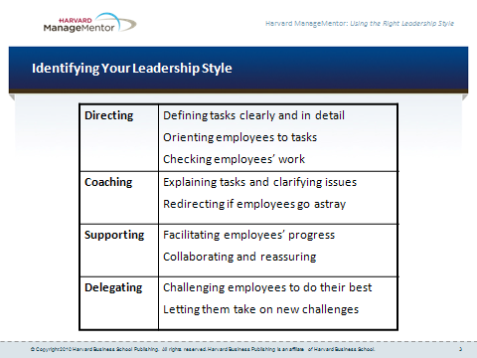
- How many of you have a sense of what your own natural leadership style is — Directing? Coaching? Supporting? Delegating?  - What kinds of things do you do that suggest you gravitate naturally toward that style? Would anyone like to share their thoughts? | - Example response:  - I see my natural leadership style as directive. That’s because I tend to define tasks very clearly and in extensive detail. And I keep checking my people’s work to make sure they’re getting the job done right.  - Note: Consider sharing your understanding of your own natural leadership style with the group. Ask the group if they see your style in the same way.  - Note: Consider showing the slide offered for this part of the discussion. It can help participants keep the four leadership styles in mind more easily as the discussion proceeds.
- Do any of you tend to use a combination of several leadership styles you’re comfortable with when working with your team members?  - If so, what are those styles?  - How did you learn to use several different styles? | - Example responses:  - I tend to feel comfortable using the coaching and supporting styles. For me, coaching is all about helping people learn new skills and that can be scary for some people. Being able to offer support and encouragement if they lack self-confidence can be really important.  - I learned how to use a couple of different leadership styles mostly from a mentor I had when I started my last job. I also read up a little bit about the subject and learned more that way.  - Note: Consider sharing your own experiences with learning how to use several different leadership styles.
- What leadership styles do you tend to avoid? Why do you avoid them? | - Note: Emphasize that awareness of styles you avoid can help you be more deliberate about using them when needed.  - Example responses:  - I really don’t feel comfortable delegating, because it feels like I’m losing control of the work.  - I don’t like being directive. I feel that people should be allowed to make mistakes, so I don’t always want to be telling them what to do.  - Note: Consider sharing your own experiences with leadership styles that feel uncomfortable for you, and explain why you tend to avoid them. For example, “When I first became a manager, I had a hard time delegating, because I thought that all of my job responsibilities could only be done by me.”

Assessing an Employee’s Developmental Level (10 minutes)
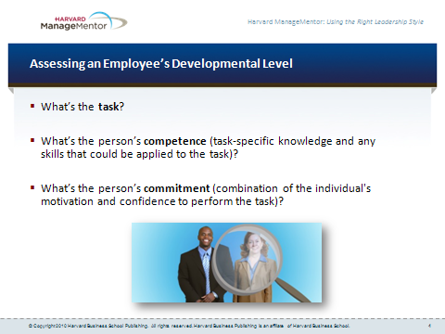
- As you know, the best leadership style to use is the one that suits the individual’s developmental level.  - Who can give an example of how you’ve assessed the developmental level of an employee from your own team? You don’t have to name names. Just share an example of a task that one of your employees is currently working on. What did you see as that person’s competence and commitment?  - How did your assessment affect the leadership style you used with that person? | - Example response:  - My employee had a lot of good expertise and knowledge but very little self-confidence. I decided that he would benefit most from the Supporting leadership style. So, I kept reassuring him that he was doing a great job. And I worked alongside him on a particularly challenging aspect of the project. The collaboration from me helped him gain confidence, I think.  - Note: Consider sharing your own experiences with assessing an employee’s developmental level and adapting your style accordingly. If you don’t feel comfortable citing an example that involves one of the discussion participants, cite one from a previous job.

Selecting the Right Leadership Style (15 minutes)
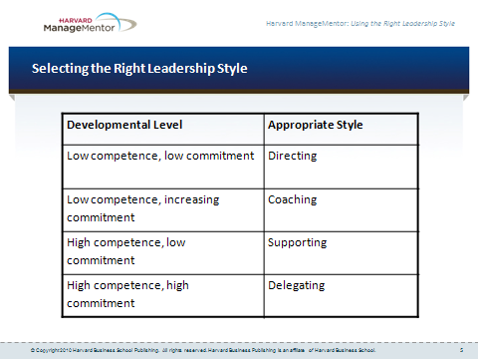
- Let’s talk now about how you can be more systematic about selecting the right leadership style depending on the employee’s developmental level.  - Take a few minutes now to pair up with a partner and talk about an employee whose developmental level is changing and who will need a different leadership style from you as he or she progresses in the job. | - Note: Encourage pairs to exchange insights and suggestions for diagnosing changes in the person’s developmental level and for selecting the appropriate leadership style.  - Example response:  - I’ve just promoted an employee to a supervisory position. I used to delegate everything to her in her old role, but now I realize that I will have to spend more time using a directive style, until she becomes more familiar with her new responsibilities.
Reconvene as a group, and ask if anyone would like to share some of their insights from their conversations.

Next Steps (5 minutes)
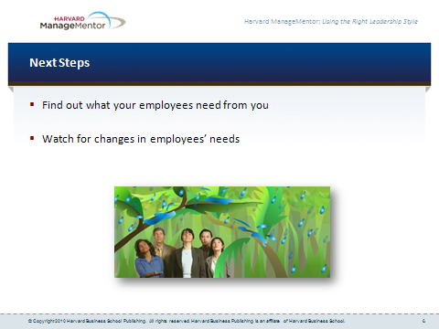
- Take a moment to consider some of the things you might do as a result of our discussion today. | For example:  - Talk one-on-one with your direct reports about what you can do to help them perform at their best. Through these interviews, they may share clues about their competence and commitment to specific tasks they’re working on. This will help you assess their developmental level and then determine the right style to use with each person.  - Over the coming months, observe how employees’ leadership-style needs may evolve. For example, maybe an employee initially needs the Directing style but later would benefit from the Delegating style.

